Abrar Mohammed

[abrarahmed0506@gmail.com](mailto:abrarahmed0506@gmail.com)| +1(352)933-7390  
5/26/2025

To,

Hiring Committee

Purpose: Personal portfolio with photo evidences of some of my projects

So far, I’ve had the opportunity to contribute to *7+ projects (2- NSF funded), 3+ publications, various international conferences & local symposiums, 1 startup, 1 patent, 4+ years* *of international work experience*

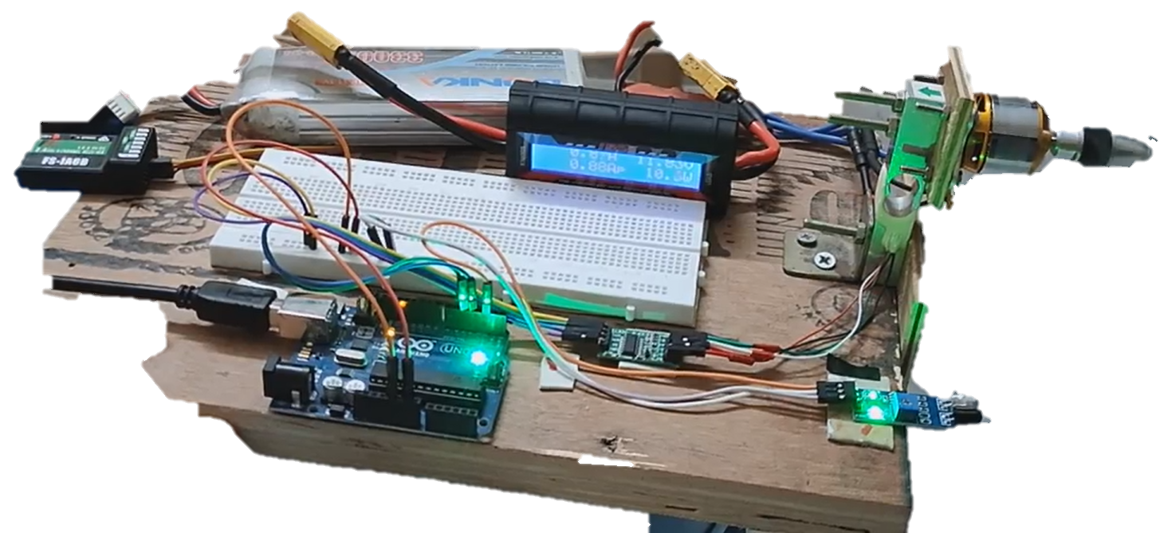

Avionics and electro-mechanical test setups with Sensors, thermal detectors, Arduino, **Camera’s hardware,** **transmitter & receiver modules** (Motor & Propeller tests)

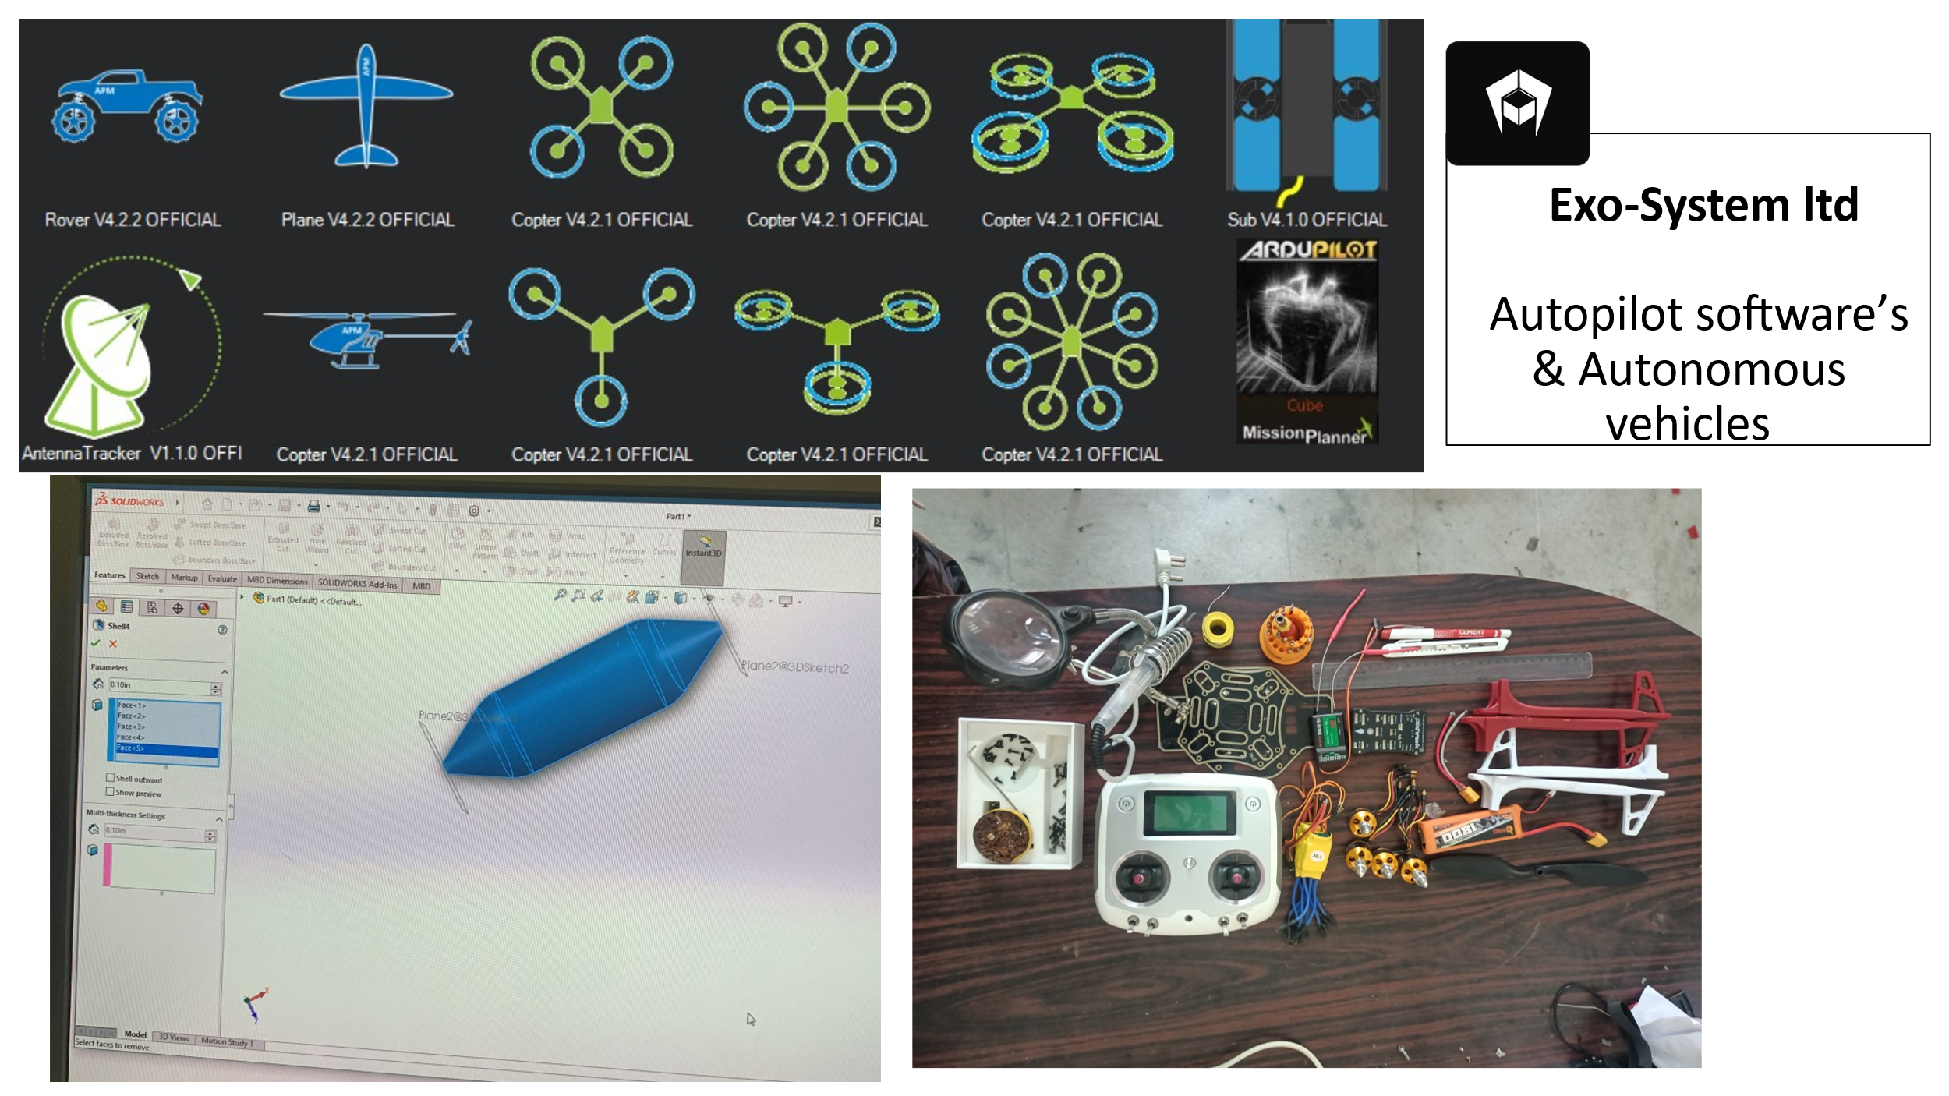

I’ve gained hands on experience with ***Siemens, Python scripting*** to develop ***structured texts & ladder logical coding*.**

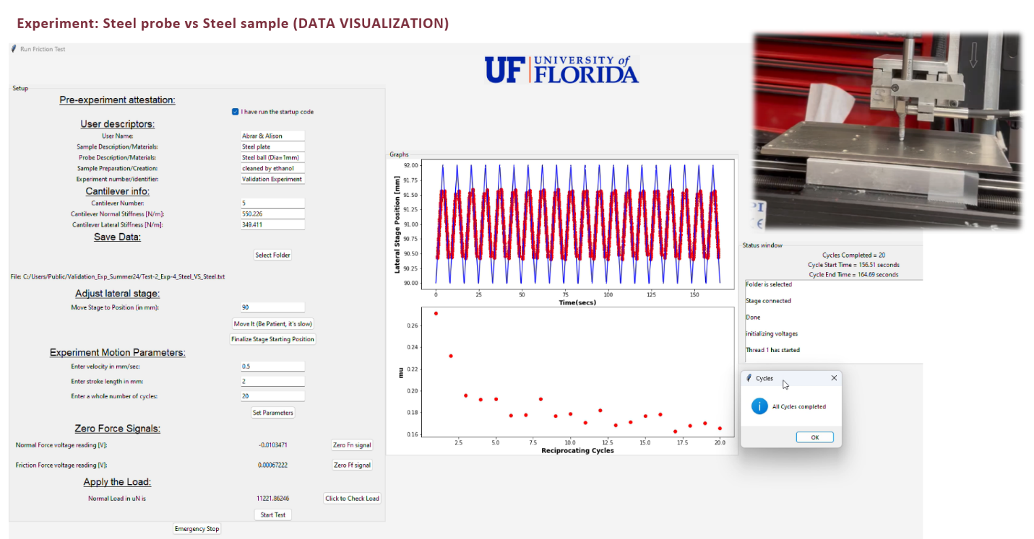

**HMI & Live data monitoring GUI Development**

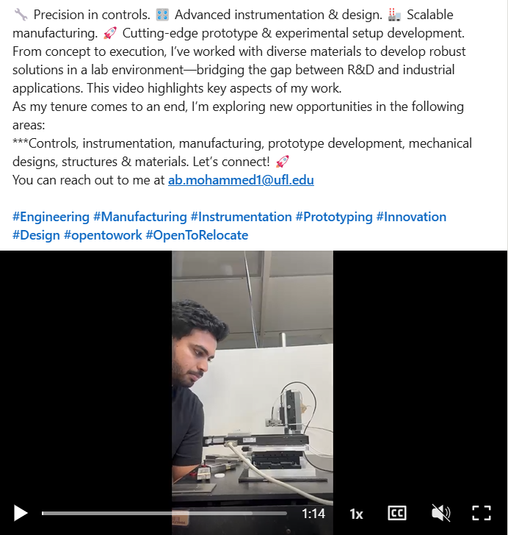

Automated the test cycle efficiency by ***40 %*** cutting costs upto ***$30,000*** on new equipments installations (see below)

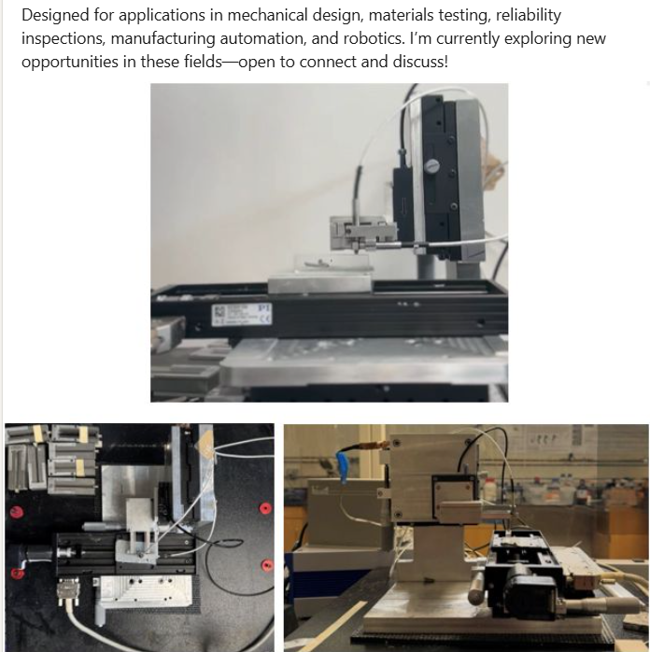

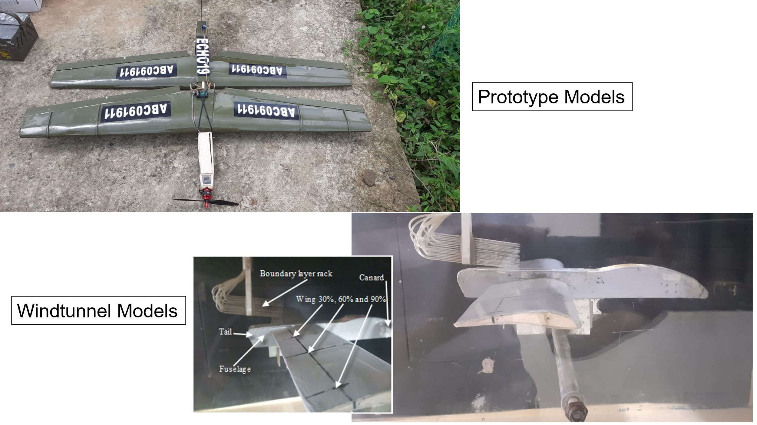

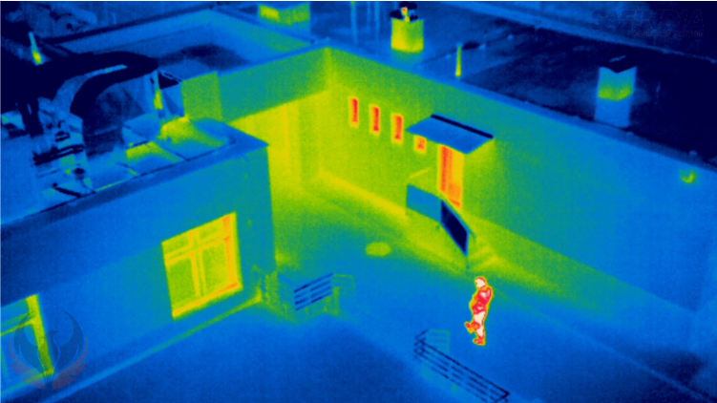

**Fire-detection Drones and Fixed wing UAVs**